|  |  |
| --- | --- |
| Roll. No.: A016, A018, A022, A028, A033, A038 | Name: Varun K, Simran K, Kartik P, Sujeet P, Shreya S, Yashasvi T |
| Sem/Year: VII/4 | Batch: 1 |
| Date of Experiment: 03/09/2022 | Date of Submission: 03/09/2022 |
| Grade -- |  |

# Aim

Setup a wireless ad-hoc network between 2 devices

# Theory

It can be done in 2 ways:

## Through WIFI

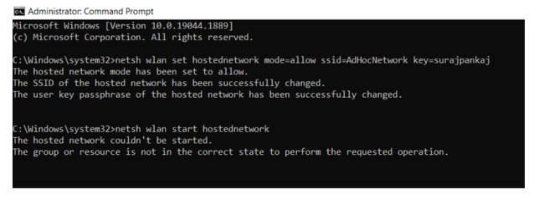

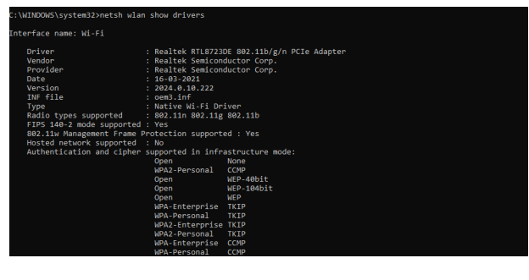

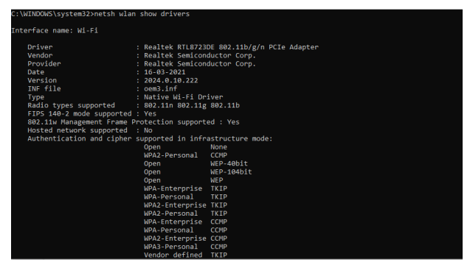

Because, ad-hoc network isn’t supported in Windows 10, Bluetooth connection was established.

## 2. Using Bluetooth

Setting Bluetooth Connection

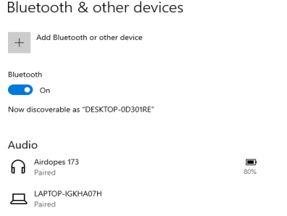

Sending the File

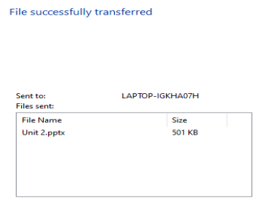

File Received

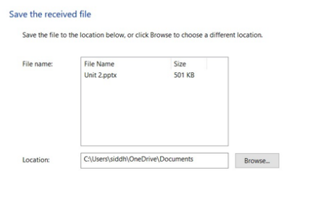

# Conclusion

Hence, we were able to established ad-hoc network between 2 systems.